**Sprint Plan 4 - NutriHall - CSE 115-A – Intro to Software Engineering - 11/19/24**

For sprint 4, we aim to finalize the design features of the front end (finalizing the dining hall selector & food diary day selector). Furthermore, we aim to finalize the AI generation for meals and push for project release.

**Task listing, organized by user story:**

User Story 1:

As a student who pays attention to their diet, I want to be suggested meal plans that fit within my restrictions and adhere to my goals.

Task 1: Further develop the existing front-end UI for meal plan suggestions. (3 hours)

Task 2: Finalize the meal plan algorithm that adheres to user restrictions and nutrition goals. (4 hours)

Task 3: Create an API endpoint to generate and return meal plans. (3 hours)

Task 4: Integrate the meal plan suggestions into the front-end interface. (3 hours)

Task 5: Test meal plan generation and ensure it aligns with user restrictions and goals. (3 hours)

Total: 16 hours

User Story 2:

As a student who eats at the UCSC dining halls, I want to responsively and easily select which college’s menu I want to see.

Task 1: Build on the pre-existing dining hall selector to make the functionality smooth. (3 hours)

Task 2: Implement more daisyUI/tailwind components and potentially other libraries to update the styling of the website. (this will be further split into subtasks for each component)

User Story 3:

As a student who pays attention to their diet, I want to see my nutritional breakdown and what I ate in previous days as well.

Task 1: Integrate additional day and calendar functionality into the food diary. (5 hours)

Task 2: Finalize the macronutrient and caloric info for each food item in the menu and food diary pages. (5 hours)

Task 3: Integrate the testing libraries to ensure all components work as intended for edge cases. (4 hours)

∙ **Team roles:**

Aiden: Developer

Violet: Developer

Artem: Developer & Scrum Master

Amish: Developer

Kevin: Developer

∙ **Initial task assignment:**

Violet: Create unit tests and general testing for previous/current user stories. Continue integration of backend components with frontend(displaying nutrient information to the frontend.

Kevin: Applying ES lint code standards. Integrate user meal preferences from the backend. Work on finalizing and fine-tuning the AI model for meal suggestions.

Amish: In the front end, overhaul the styling of the website using daisyUI, and tailwindCSS. Finalize caloric and macronutrient info for each food item.

Aiden: Finalize the web-scraper, work on finalizing the AI model, and create the front-end components to display the AI-generated meals.

Artem: Build on the pre-existing dining hall selector to make the functionality smooth. Integrate additional day and calendar functionality into the food diary. (5 hours)

∙ **Initial burnup chart:**

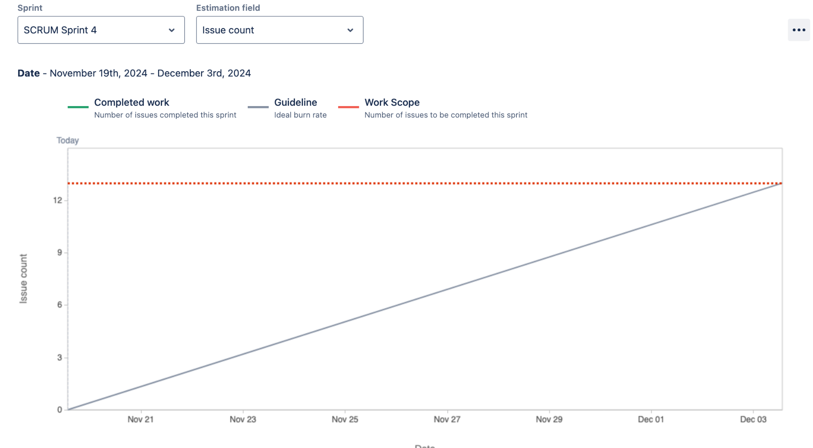

∙ **Initial scrum board:**

**Next page**

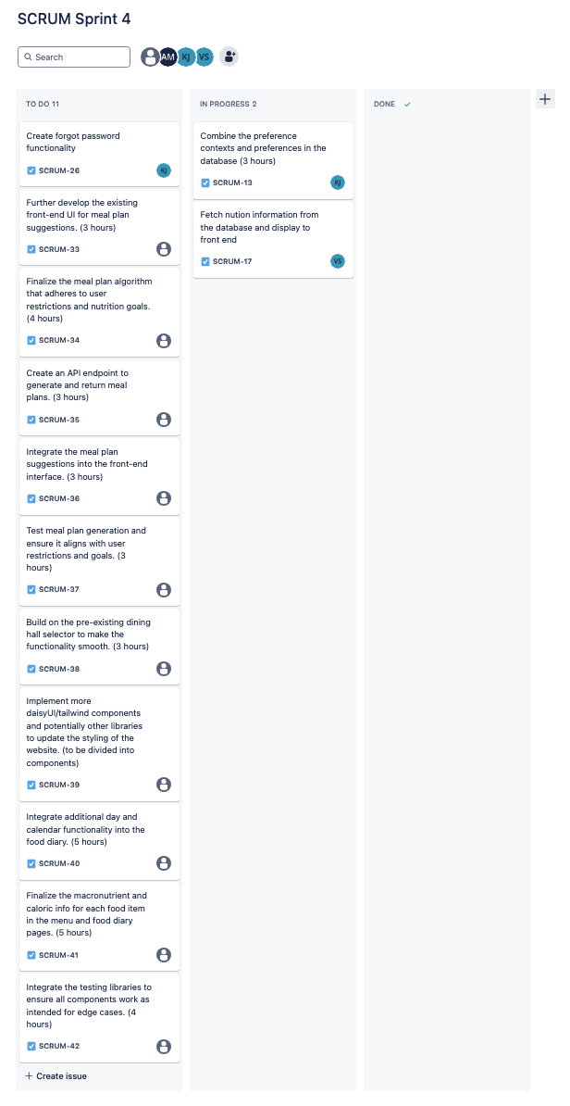

∙ **Scrum times:** Monday @ 2:30pm, Saturday @ 12pm, and Thursday 1:45pm

